SPRINT-2

Date | 02 NOVEMBER 2022
TEAM ID | PNT2022TMID04063
Project Name | IoT Based smart crop Protection system for agriculture
Maximum mark | 20 marks

STEP1: Setup Node-Red

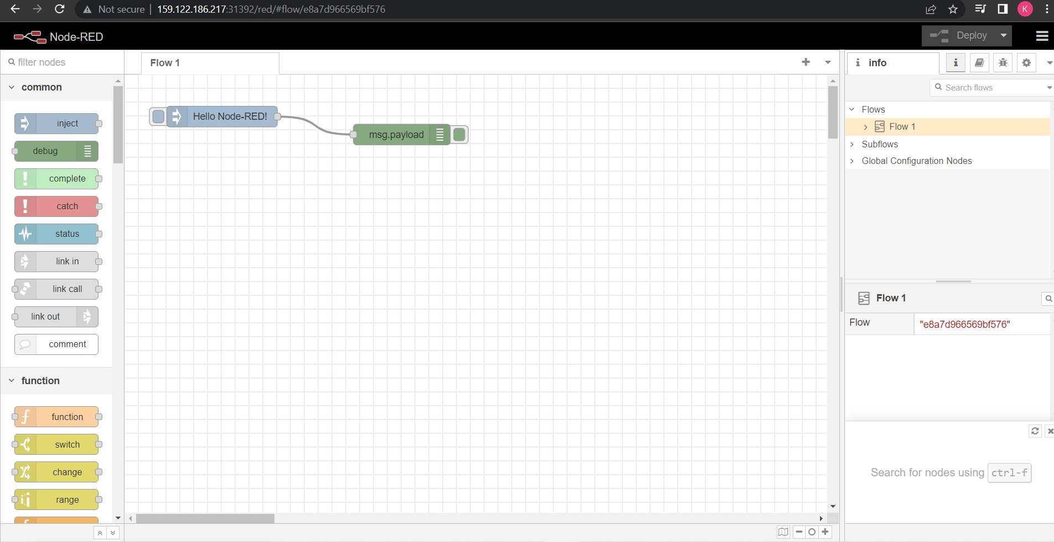
STEP 2: Connect IBM IOT in and Debug 1 and Deploy.
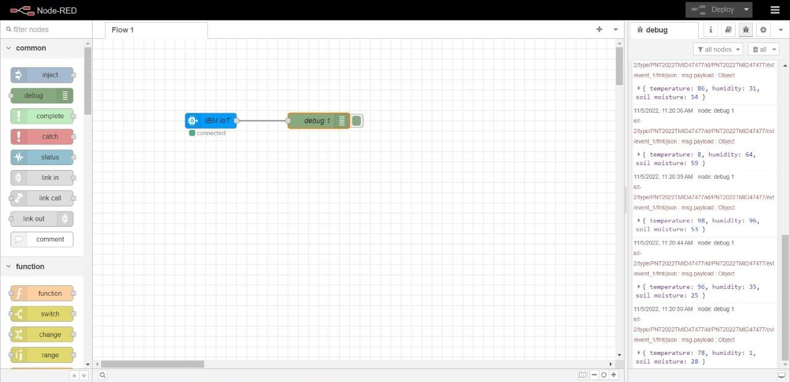

STEP 3: Edit gauge node (Here the gauge nodes are named as Temperature, Humidity and Soil moisture).
